

**Laura (Johnson) Cross, Chris Cross & Alya and Jack Cross**

**Photo about 2011-2013**

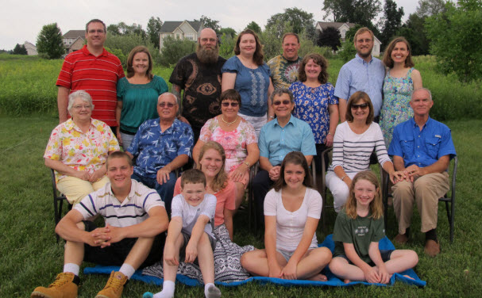

**Roger & Jessie Wolfe Descendants**

**l-r, Back Row: Chris Bell, Elaine Bell, Douglas Polczynski, Diane Polczynski, Chris Cross, Laura Cross, Greg Rigelman, Renee Mettle**

**Center Row: Norma Jean Hill, Dennis Mettle, Joy Johnson, Larry Johnson, Kathy Johnson, Bob Johnson (Larry and Bob Johnson are brothers)**

**Front Row: Evan Bell, Jack Cross, Emily Bell, Lydia Bell, Ayla Cross**

**Photo taken 29 June 2014 in Howell, Michigan**